Corner Grocer Item-Tracking Program
Pendeza Alimasi
Southern New Hampshire University
CS-210 Programming Languages
Professor Tricic
April 19, 2026

Corner Grocer Item-Tracking Program
For this project, I created a C++ program that reads grocery item data from a text file and tracks how often each item is purchased. The purpose of this program is to help the Corner Grocer understand which items are bought the most so they can organize their store layout more effectively. The input file contains different produce items listed one at a time, and many of them repeat throughout the file.
To build the program, I used a class called PurchaseCounter to organize the code. Inside this class, I used a map to store each grocery item along with how many times it appears. This made it easier to update counts as the program reads through the file. One of the screenshots shows part of this class, including functions like getItemCount, printAllFrequencies, and printHistogram, which handle the main features of the program.
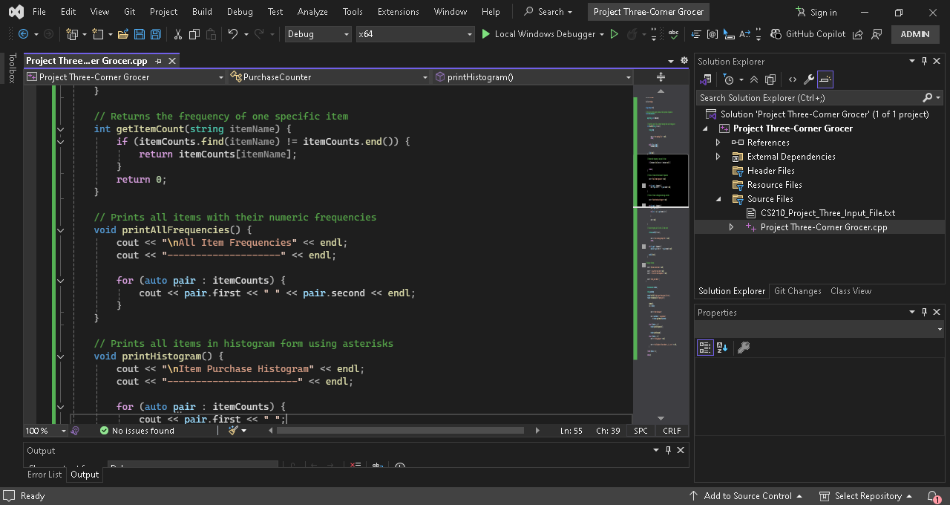
When the program runs, it first loads the input file and counts all the items. It also creates a backup file called frequency.dat, which stores each item and its frequency. This can be seen in the screenshot where the program prints “Backup file created!” before displaying the menu. This confirms that the file output functionality is working correctly.
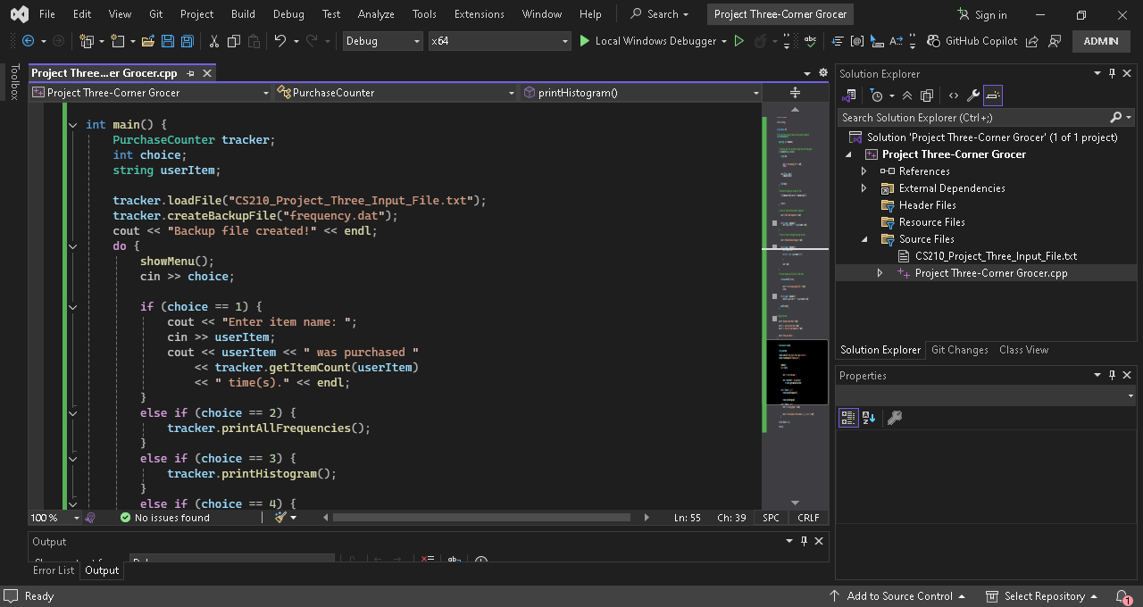
The program then displays a menu that allows the user to interact with the data. The user can search for a specific item, print all item frequencies, display a histogram, or exit the program. In one of the screenshots, the user selects option 1 and searches for items like Garlic and Cranberries. The program correctly returns how many times each item was purchased, showing that the search functionality works as expected.
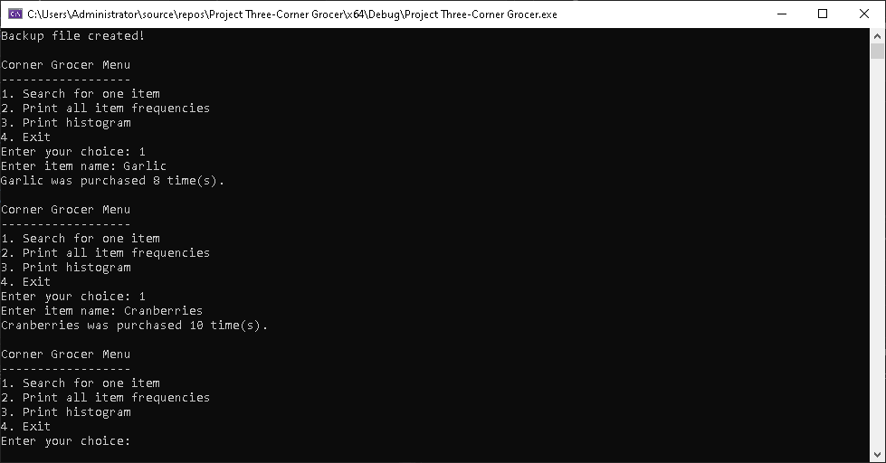
Another feature of the program is the histogram display. This shows each item followed by a series of asterisks representing how often it appears. This makes it easier to visually compare which items are purchased more frequently. The histogram output demonstrates that the program correctly translates numeric data into a visual format.
Overall, this project helped me understand how to work with file input and output, use maps to store and organize data, and structure a program using classes. It also showed me how to build a menu-driven program that allows user interaction. I feel more confident now in writing C++ programs that are both organized and functional.

